I did some research on versioning. Semantic versioning is the standard and it starts with 1.0.0

If a project is going to be shared with others, it should start at 1.0.0

After initial release, changes should be handled as follows:

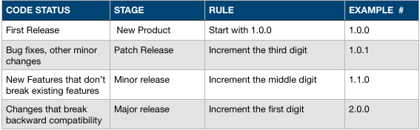

**Downloading External Packages for our project:**

While Downloading external packages there are multiple options we can use to specify version numbers in Package.json

1. Default: Must match exact version (eg: 1.3.0)
2. tilde(~) : the tilde matches the most recent minor version (the middle number). ~1.2.3 will match all 1.2.x versions but will miss 1.3.0
3. caret(^) : The caret, on the other hand, is more relaxed. It will update you to the most recent major version (the first number). ^1.2.3 will match any 1.x.x release including 1.3.0, but will hold off on 2.0.0
4. * : Which will get current version which includes major changes, which will definitely impact current behaviour of downloaded packages. * is definitely not an option.

**Conclusion:**

With this analysis I believe it would be good to go with **tilde(~)** versioning while downloading external packages.

* Default: means we will fix with one version and going to miss any bug fixes which original package developers implemented on later date.
* Caret(^): we may not need additional features which other (external) packages offer later part of this project.
* Tilde(~) : We will get all the current functionalities and any bug fixes to those functionalities without impacting existing behaviour.

Ref:

<https://docs.npmjs.com/getting-started/semantic-versioning>

<https://stackoverflow.com/questions/22343224/whats-the-difference-between-tilde-and-caret-in-package-json>